VISVESVARAYA TECHNOLOGICAL UNIVERSITY

Belgaum-590014

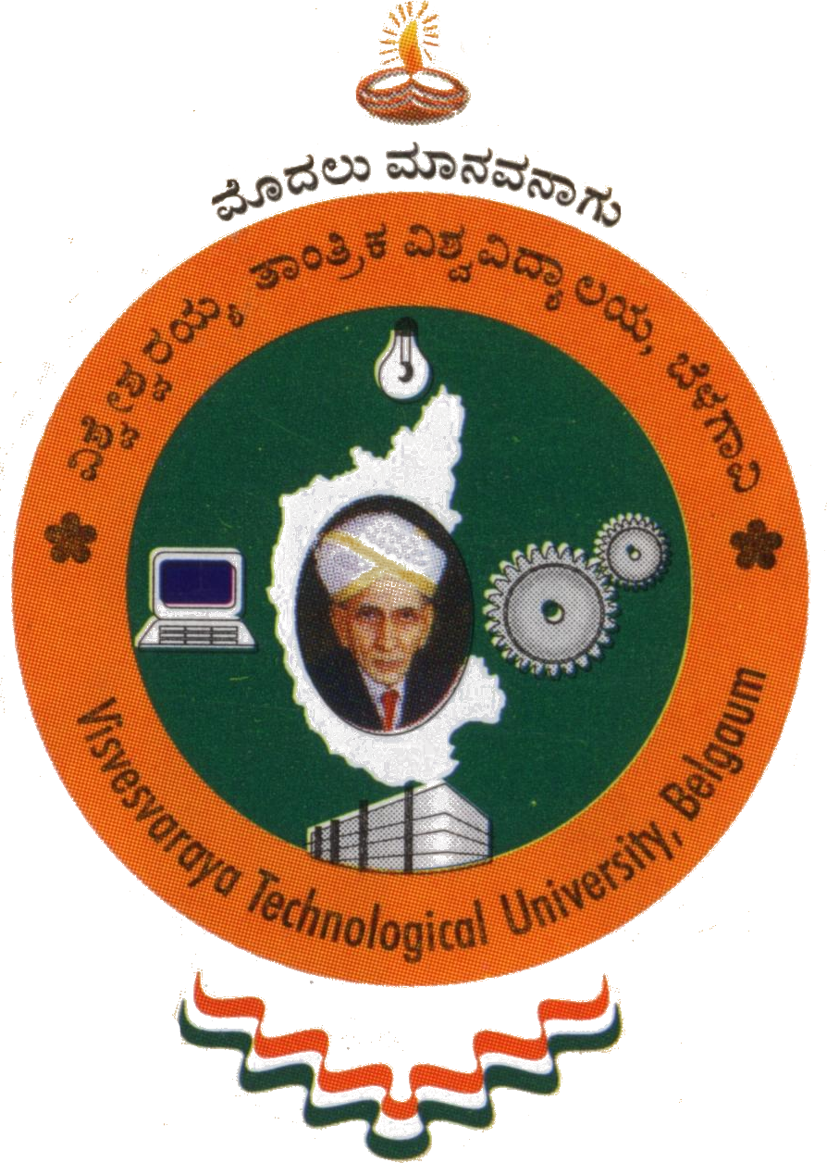

Project Report
On
“HAND-CRICKET”

Submitted in partial fulfillment of the requirements for the VI Semester

Computer Graphics and Visualization Lab (10CSL67)

Bachelor of Engineering

IN

COMPUTER SCIENCE AND ENGINEERING

For the Academic year
2013-2014

BY
NAGABHARAN.N 1PE10CS054
NAVEEN KUMAR.M 1PE10CS056



Department of Computer Science and Engineering
PESIT BANGALORE SOUTH CAMPUS
HOSUR ROAD
BENGALURU-560100

PESIT BANGALORE SOUTH CAMPUS
HOSUR ROAD
BENGALURU-560100

DEPARTMENT OF COMPUTER SCIENCE AND ENGINEERING

CERTIFICATE

This is to certify that the project entitle “HAND-CRICKET” is a bonafide work carried out by NAGABHARAN.N and NAVEEN KUMAR .M bearing USN 1PE10CS054 and 1PE10CS056 respectively, in Computer Graphics and Visualization Lab (10CSL67) for the 6th Semester in partial fulfillment for the award of Degree of Bachelor of Engineering in Computer Science and Engineering of Visvesvaraya Technological University, Belgaum during the year 2013 - 2014.

--------------------------- ---------------------------
Signature of the guide Signature of the HOD
Sarasvati.V Dr.Srikanta Murthy
Assistant Professor. Head of the Department
Dept. of CSE Dept. of CSE
PESIT BSC, Bengaluru. PESIT BSC, Bengaluru.

